Imperfections in OPAMP’s

Reel opamp’s are of cause not perfect. Initial it’s OK to consider an OPAMP as ideal, but in real circuits it’s necessary to know the imperfectness and eventually faults caused by this.

Here there are listed some of the parameters, with an explanation. For some, there are shown how to solve the problems.

Parameter: | Explanation:
Input Current,  Input bias current | The current I in the Input terminals are not = 0. Depending of the OPAMP type, there always will flow a small current, into or out of the input. This current is called the Input Bias Current.  The Input Bias current can exixt of the Base current in the input transistor, or the gate current if the input is applying FET-transistors.  The quantity of the Input Bias Current is from a few n[A] for BJT = normal bipolar transistors to p[A] for FET-inputs.
Input offset current  I_{os} | Here is understood the difference between the two input bias currents. I_{os}.  Typically values for offset current is ½ to 1/10 of the bias current.  In order to solve this problem, there normally are mounted the same resistance in both inputs. It lets the OPAMP “see” the same resistance from its inputs!
Input offset current  I_{os} | 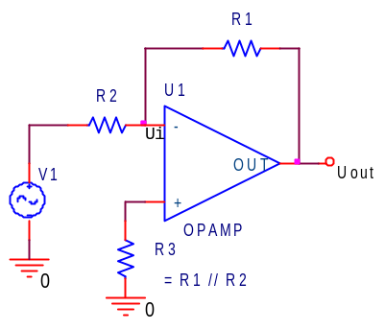 |  | 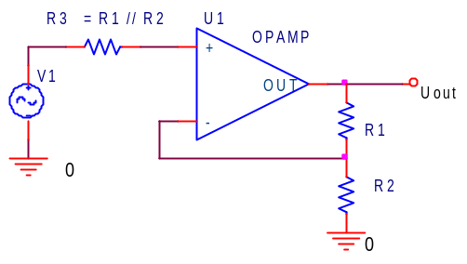
Input impedance | Input resistance the resistance, appering into the input, when the other input is grounded.  For BJT – input Opamps it is round 2 Mohm, and for FET fx. 10¹² ohm.
Common-mode input range

Input voltage range | The input voltage should not be more than the supply voltage. For some types, the input voltage even shouldn’t come closer to the rails, than a couple of Volts.  Some newer opamps allows input voltages from ”Rail to Rail.”  For an opamp working with ±15 Volt, the guarantied Uinput can be as low as ±11 Volt. If the input voltage excides this, the output can behave in a wrong way.  LM358 can “sense near ground. “ It means, it can measure voltages near zero, even at single supply. – Or near the negative supply voltage.
Differential input range | Some OPAMPS do not allow the difference in voltage applied to the inputs to be more than fx. ± 0,5 Volt.  The solution can be to place two diodes in opposite directions between the two inputs.
Output impedance, | Output resistance, or impedance is the resistance that can be measured backwards into the opamps output, at the middle of the signal, and with no feed back.  It’s measured in ohm. Fx 40 ohm. For some low power op-amps it can be as big as several Kohm.  Feed back can reduce Rout.
Max Iout | Typisk kan en op-amp levere / synke fx 20 mA. Trækkes for meget strøm, kan Uout swing ikke blive så stor.  Nogle opamps kan levere ret stor strøm, Kaldes ”power-opamps”.
Output swing, | Uout normally cannot swing out to the rails. Meaning to the supply voltage.  LM358 can on its outcut come close to the negative rail, which is smart at single supply.
Voltage gain and phase shift. | Typpical values for a DC open loop gain can be fx 10^{6.} Often given in dB.  But at rising frequencies this gain decrease until it reaches unity gain, that means one times, or 0 dB at a frequency of fx. 1 to 10 MHz. This frequency is called f_{T}.  If the opamp is internally compensated, that means, it internal has been supplied with a dominating capacitor, the Bode plot for the open loop gain will show a gain roll off from fx 10 Hz. The roll off is - 20 dB / decade.  The open loop band width is then 10 Hz.  Because of the internal capacitor there also will appear a phase shift on the output. This is already 45 degrees at the corner frequency. ( 10 Hz )  The capacitor is applied in order to control the gain roll off. If it fx because of small capacitance on the chip causes a gain roll of more than –20 dB/decade, negative feed back can turn into positive feedback, and so cause oscillations.  Some OPAMP’s should have an external capacitor mounted
Input offset voltage  U_{os} | Op-amps do not have an perfect balanced input. If both inputs are tied to the same voltage, fx 0, there always will be a –small – voltage on the output.  The voltage necessary on one of the inputs in order to give the output equal zero, is called U_{os}. Values is fx 0,8 mV.  Using fx the following circuits, U_{OS} can be eliminated. With the potentiometer, the viltage on one input is pulled a bit to the one side.  Some OPAMP’s has terminals to adjust the U_{offset}. Fx. The old 741.
Input offset voltage  U_{os} | 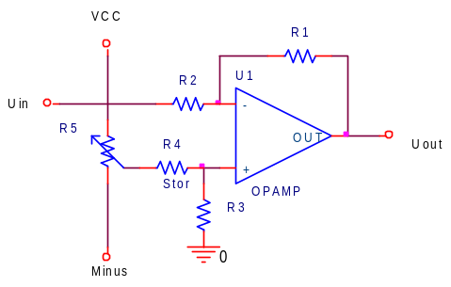 | 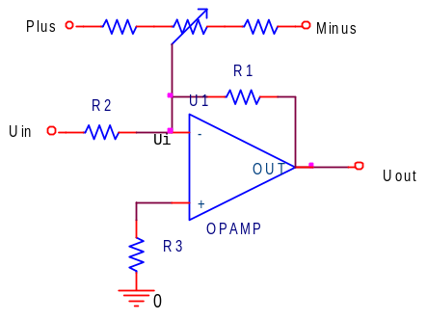
Offset drift: | The input offset voltage even is not constant at different temperatures. The input offset drift is given in μV / ºC. Values can be a few μV / ºC.
Slew rate  SR | The maximum change in output voltage is limited. It is measured in V / μs.  It is because of small capacitances on the chip. Even a small capacitor cannot be charged within no time.  Example:  The max voltage change for an 1 MHz 3 Volt RMS sine voltage is calculated.  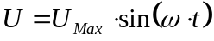 ω is in radians.  To find the slope of the sine, we differentiate:  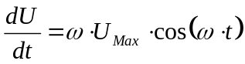  Max value of the Cosine is 1, so we get:  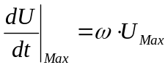  ω = 2πf, and the peak value of a sine voltage is √2 times the RMS-value. So:  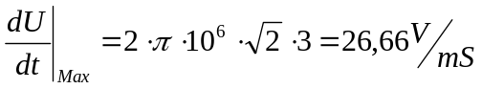  The max voltage change is 26,66 Volt pr mS.  For an Opamp the formula is:  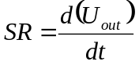= 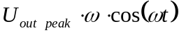  The slope is max at t=0. This and cos(0) = 1 is used:  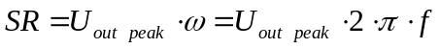  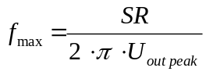  SR-values for an LM358 ~ 4 [V / μS]. Other opamps are much faster, fx 6000 [V / μS].  The Slewrate decrease the amplitude of a sine-signal on the output. If the slope of the sine in its zero-crossing should be bigger than the SR for the OPAMP, the signal will be distorted.  The following sketch shows the principle. Two unity gain ( 1 time ) amplifiers are applied a 20 V_{pp} signal at rising frequencies. Uout is measured.  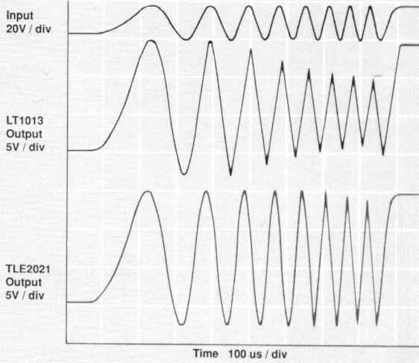  TLE2021 can handle a 20 V_{pp} signal at 14 Khz without distortion.  LT1013 starts to slewrate Uout at 6 KHz.
Open loop voltage gain | The open loop gain is not infinite. Realistic values from 10⁶ til 10⁷  See special section !
Output current | The output current is not infinite. An opamp can fx source or sink 10 mA.  High power opamp’s exists.
Unity gain Bandwidth  ~ 3 dB | That frequency, where the gain, when amplifying 1 times, has fallen to 0,707 times. This equals –3 dB.
Gain Bandwidth product. | The gain times the band width is constant = unity gain
CMRR | Common mode rejection ratio. Measured in dB !  CMRR means how good the opamp is to prevent output influences from equally signals on the two inputs.  This appears fx if there are used long wires to a signal source, where electrical noise is present.  .  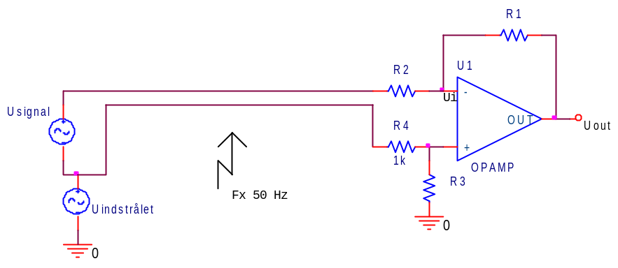  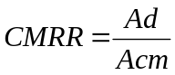 Ad is the gain in different mode, Acm is the gain in common mode, = on both inputs.
PSRR | Power supply rejection ratio. Express the influency from noise on the power supply, = Power supply sensitivity.

Gain Bandwidth

First we look at the following circuit:

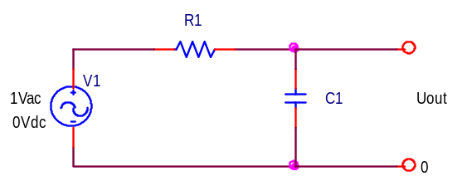

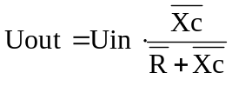 → 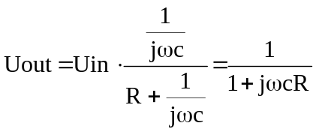

The transfer function then is:

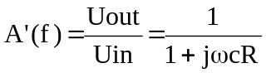 (1)

The transfer function also can be written as: 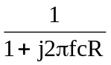 (2)

At the break frequency 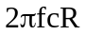=1. This means, that 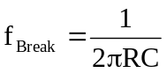, or 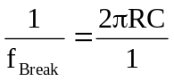

This is substituted in (2), and we get a standardised equation for the gain:

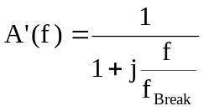 (3)

f_{Break} = f_{B} is the corner frequency.

OPAMP:

At DC, the open loop gain of an OPAMP typically is between 10⁵ and 10⁶. But at higher frequencies the gain is a function of the frequency. It becomes smaller in magnitude at high frequencies.

Normally has the designer of the OPAMP limited the gain at high frequencies to avoid problems with oscillations when feed back is used. This is dome by placing a dominating capacitor on the chip. And this gives the transfer function an dominant pole.

An example for the open loop gain for a LM324 OPAMP is shown here:

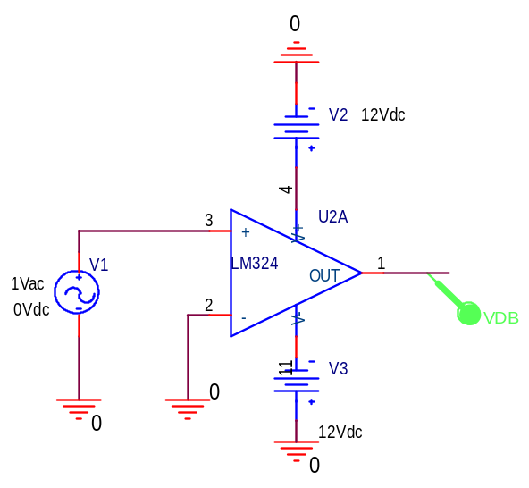

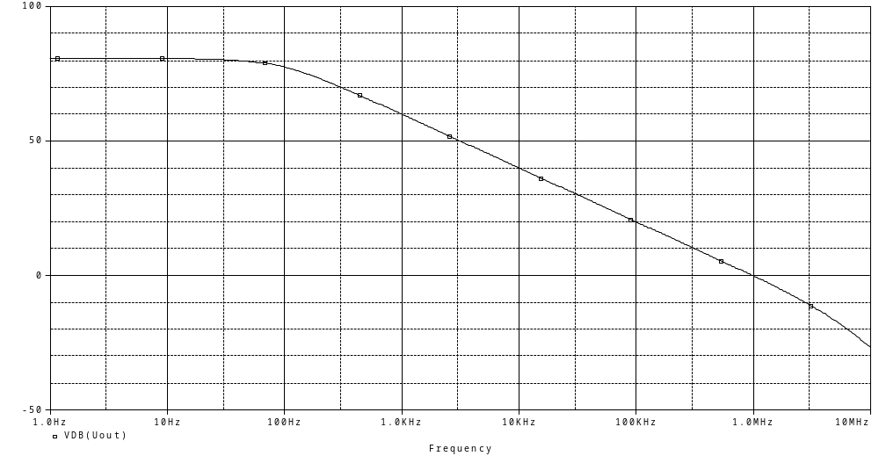

An OPAMP has a similar Open Loop transfer function with one dominant pole.:

The transfer function is:
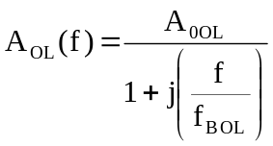 (4)

A_{0 OL} is the DC open loop gain, and f_{B OL} is the open loop break frequency.

In a Bode Plot of A_{OL}(f), the gain magnitude is approximately constant up to f_{B OL}. Above f_{B OL} the gain magnitude rolls off at 20 dB/decade.

Now we consider the following circuit:
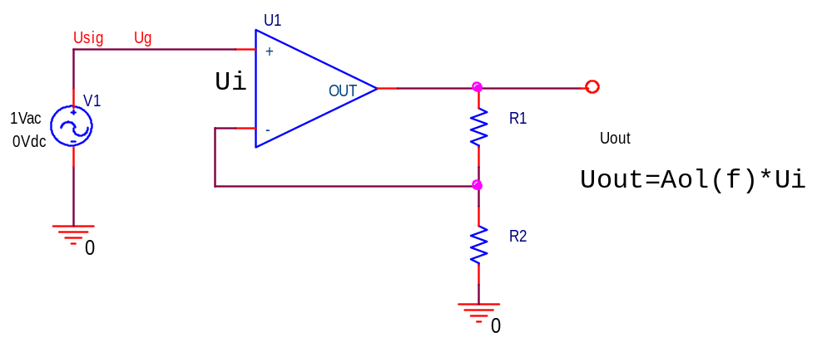

The feedback network consist of R1 and R2. They act as voltage divider:

The voltage that is feed back is given by 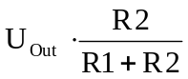 (5)

The ratio of the feed back is normally called , so 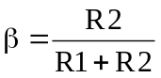 (6)

For the above circuit can be written the following equation:

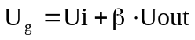, and 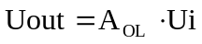 (7)

These gives: 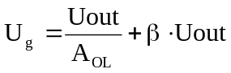 (8)

The closed loop gain is Uout/Uin, so (8) rearranged gives:

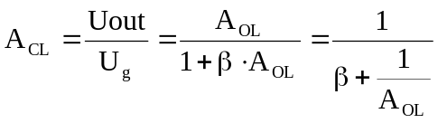 (9)
If the OPAMP is ideal, 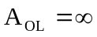, giving (9) = 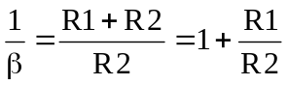 (10)
which is as known !

Again, we consider eq. (9), 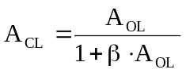 (11)

From (4) we have:
Substituting (4) into (9) gives:

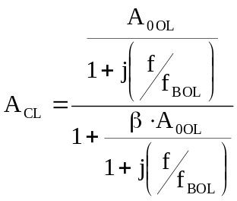 (12)

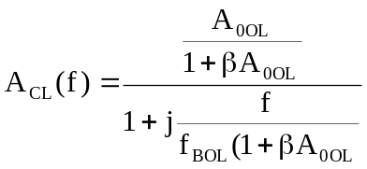 (13)

If 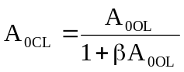 , ( DC-Closed Loop ) (14)

And

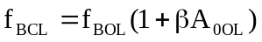 , ( f Break Closed Loop ) (15)

the eq. (13) can be expressed

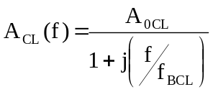 (16)

This equation, the closed loop gain, has the same form as the open loop gain (4). The Bode Closed Loop gain looks similar to the open loop gain, but the DC-loop gain and the break frequency have different values.

Again simulating using a LM324, with β= 0,01 as the following circuit:

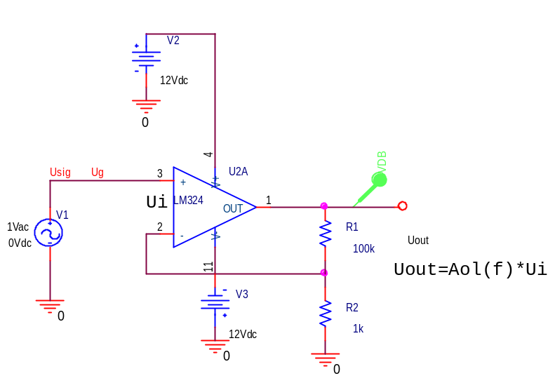

The Bodeplot:
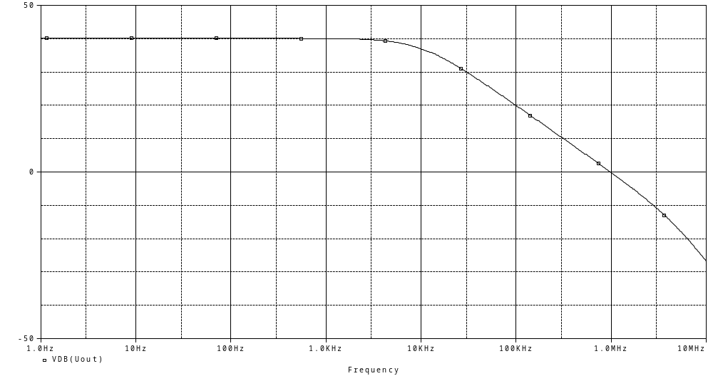

And Beta = 0,1:
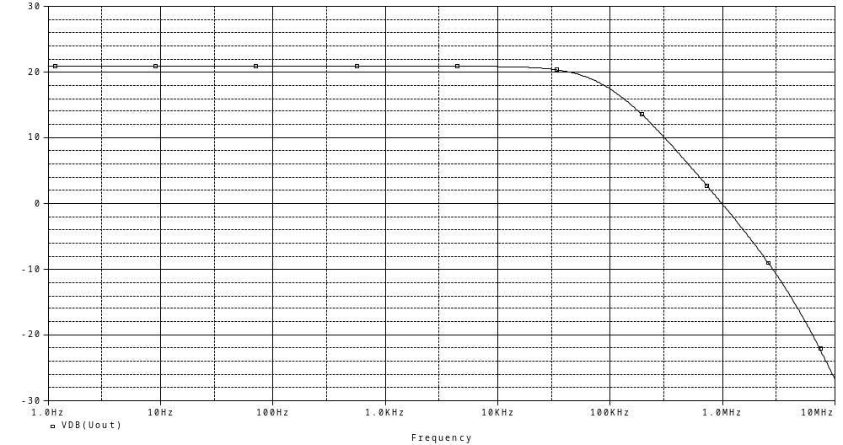

All together looks like this::

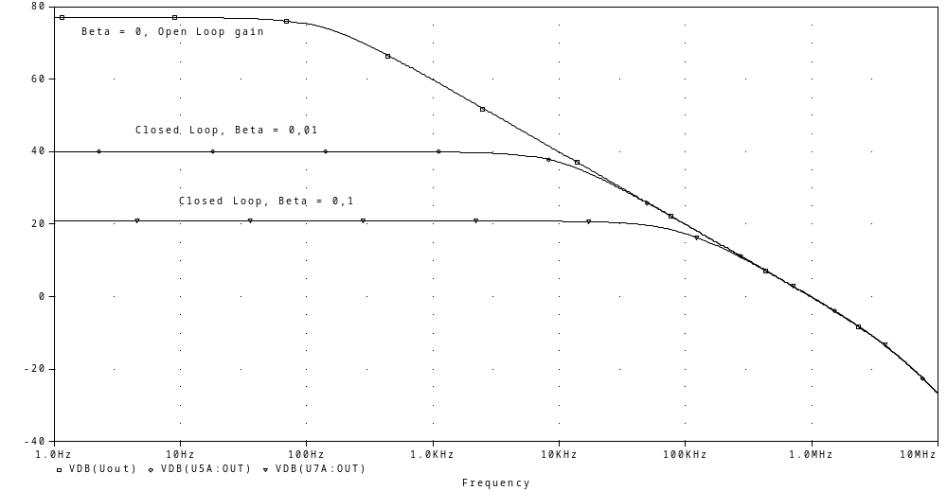

The DC Closed Loop can be calculated from (14) = ,

and the closed loop break frequency from (15) =

As beta increases, the DC-gain becomes lower, and the band with becomes wider. And the roll off of all the Bode plots are the same.

If the two left sides from (14) and (15) are multiplied, and also the right sides, we get:

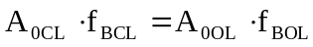 (17)

We see that the product of the left side of (17) is a constant, independent of beta.
This means, that the dc-gain times bandwidth is constant.

The gain-bandwidth product = f_{t} =

The gain-bandwidth product = f_{t} is also the frequency, at which the Bode plot of the open loop gain crosses 0 dB. Thus the gain bandwidth product is also called the Unity gain bandwidth.

Negative feedback reduces the dc gain of an amplifier and extends its bandwidth

Appling more cascade coupled amplifiers gives better bandwidth than one amplifier with higher gain !

